[AngularJS](https://www.toptal.com/angular-js) is a JavaScript MVC framework developed by Google that lets you build well structured, easily testable, and maintainable front-end applications.

**AngularJS** is a web application framework designed to simplify rich client-side application development. This documentation is for Angular 1.x, the predecessor of the more modern Angular 2+.

**Installation Steps:**

We need the following tools to setup a development environment for AngularJS:

1. AngularJS Library
2. Editor/IDE
3. Browser
4. Web server
5. **AngularJS Library:**

To download **AngularJS** library:

Go to [**angularjs.org**](https://angularjs.org/) -> Click on **DOWNLOAD ANGULARJS**

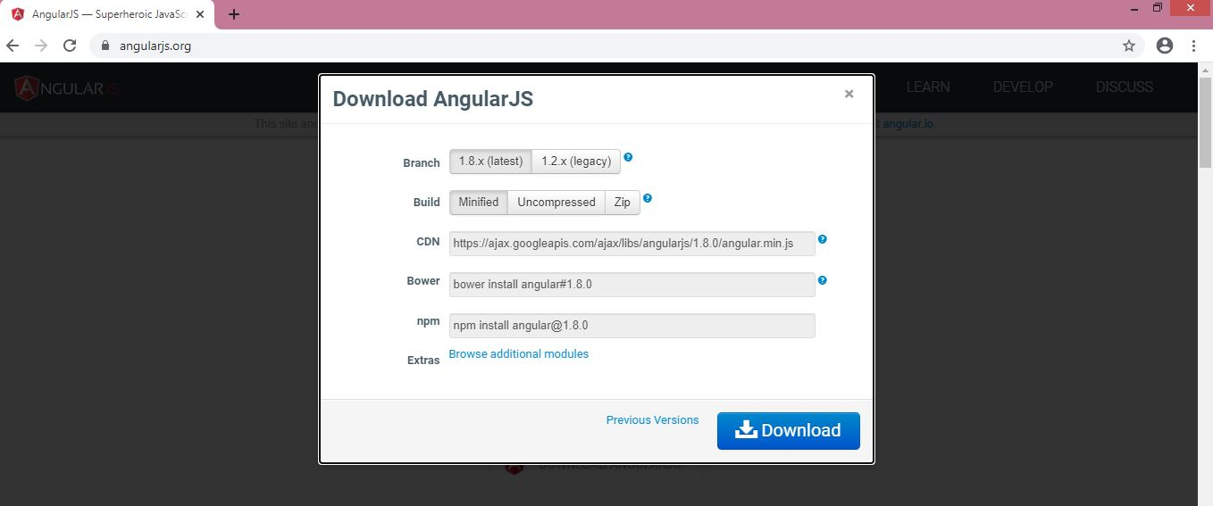

Select the required version from the popup and click on **Download** button in the popup.

## Editor:

AngularJS is eventually HTML and JavaScript code. So you can install any good editor/IDE as per your choice.

The following editors are recommended:

* Eclipse IDE for Web and JavaScript Developers - 2020-06
* Microsoft Visual Studio Code

## Online Editor:

You can also use the following online editors for learning purpose.

* [plnkr.co](http://plnkr.co/)
* [jsbin.com](http://jsbin.com/)

## Browser:

You can install any browser of your choice as AngularJS supports cross-browser compatibility. However, it is recommended to use [Google Chrome](https://www.google.com/chrome/) while developing an application.

1. **Web Server:**

Use any web server such as IIS, Apache, etc. For local development, you can use <http://localhost:4002>.

## Install the Angular CLI

You use the Angular CLI to create projects, generate application and library code, and perform a variety of ongoing development tasks such as testing, bundling, and deployment.

To install the Angular CLI, open a terminal window and run the following command:

**npm install -g @angular/cli**

## Create a workspace and initial application

To create a new workspace and initial starter app:

1. Run the CLI command ng new and provide the name my-app, as shown here:

**ng new my-app**

1. The ng new command prompts you for information about features to include in the initial app. Accept the defaults by pressing the Enter or Return key.

The Angular CLI installs the necessary Angular npm packages and other dependencies. This can take a few minutes.

The CLI creates a new workspace and a simple Welcome app, ready to run.

## Run the application

The Angular CLI includes a server, so that you can build and serve your app locally.

1. Navigate to the workspace folder, such as my-app.
2. Run the following command:

**cd my-app**

**ng serve –open**

**{you can also use “ng serve”}**

The ng serve command launches the server, watches your files, and rebuilds the app as you make changes to those files.

The --open (or just -o) option automatically opens your browser to http://localhost:4200/.

If your installation and setup was successful, you should see a page similar to the following.

**First AngularJS Application:**

Open the editor and create a **test.html** file:

<!DOCTYPE html>

<html>

<head>

<title>First AngularJS Application</title>

<script src="https://ajax.googleapis.com/ajax/libs/angularjs/1.3.16/angular.min.js"></script>

</head>

<body ng-app >

<h1>First AngularJS Application</h1>

Enter Numbers to Multiply:

<input type="text" ng-model="Num1" /> x <input type="text" ng-model="Num2" />

= <span>{{Num1 * Num2}}</span>

</body>

</html>

**Run the application:**

# First AngularJS Application

Enter Numbers to Multiply:  x  = 12